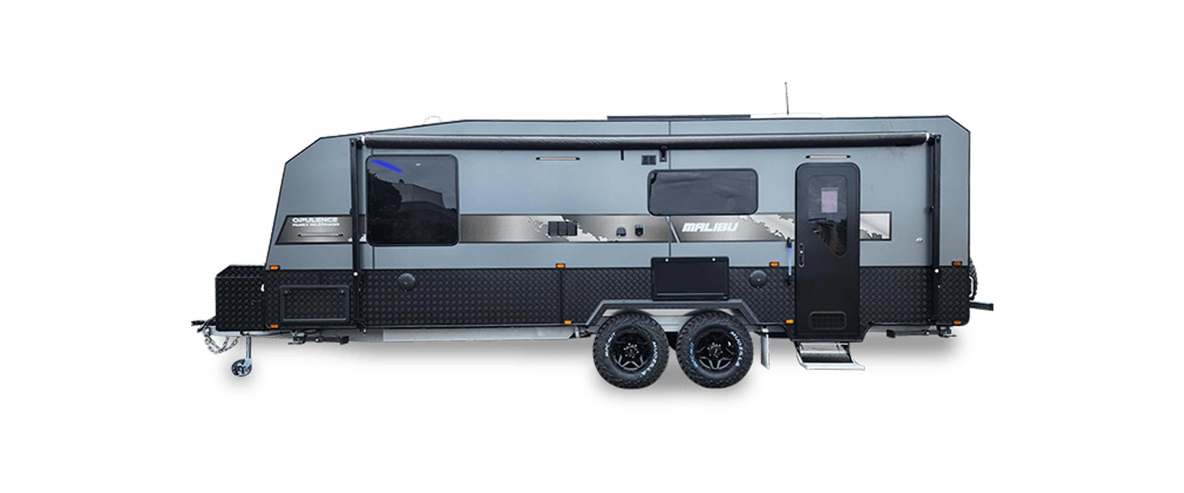

Length: 22.6ft
Ball weight: 200kg
Tare: 2680kg
Atm: 3500kg
2023 Model New

Chrome accessories
190l Compressor fridge
Full oven
6’Heavy Duty Chassis
Alko independent suspension
Quick Release Drop Down Jack
2 x 95 Litre Water Tanks
8’ Jockey Wheel
16’ All-Terrain Tyres & Alloy Wheels
Control rider TS D035 hitch
Heavy Duty Rear Bumper Bar
Spare wheel
X2 9kg Gas Bottle Holders
Alucomp External Body
Generator Provision
3 Point Locking Security Entry Door
Pull Out Step
Toolbox
Checker-Plate Wheel Spats
Extended A-Frame Jockey
Electric Brakes
Roll Out Awning
Illuminated Grab Handles Insulation
Eurovision Double Glazed Windows
Checker-Plate Internal Step
Drop Down Picnic Table
Full Insulation Midgee Blinds and Fly screens High Checker-Plate Front and Sides
J-Mould Surround (Black)
APPLIANCES & ELECTRICAL
X2 Dual Annex Lights
X2 100AH DC 12v Battery
Low Profile Reverse Cycle Air-Con Houghton
12v ATV Fan
24" Flat screen TV on swivel arm
Double Power-Points Throughout 12v & 240v Bed Side Points
LED Tunnel Boot Light
12v Hatch with Light
12v LED Number Plate Light
240v 15a Inlet (and Outlet)
LED External Clearance Lights
Breakaway Safety System
Grey Anderson Plug
12 Pin Flat Trailer Plug
Smoke Detector
External 240v & 12v Points
Door Side LED Tunnel Boot Light
Front and Rear LED Spotlights
Winegard TV Antenna
2x 170watt Solar Panels
BMPro Battery Management System
Safety Dave Rear Camera with Car Kit
20L Microwave
Flush Mount 12v NCE Range hood
AM/FM/CD/MP3/Radio Player X2 Internal and External Speakers
12v LED Strip light above Bed
12v LED Strip light around Step Entry
12v LED Downlights Throughout
Solar Regulator
12v LED Reading Lights Throughout
12v & 240v Bed Side Points
TV WIFI INTERNAL
Deluxe L Shape Dinette or club lounge with Telescopic table High gloss acrylic doors
Piano hinges
Full-size pull-out pantry
3.2kg Top loader washing machine
Upholstered Bed Head
Magazine Pockets throughout
Gas Struts on all OHC’s
Full ensuite with Vanity Dual Sky Hatches
Ceramic toilet
Full Height Splashbacks
Lift up Queen Bed
Pillow top queen mattress
2 year structural warranty

